

**IT2120**

**Probability and Statistics**

**Year 2 – Semester 1**

**Lab Report - 02**

Submitted to

Sri Lanka Institute of Information Technology

In partial fulfillment of the requirements for the

Bachelor of Science Special Honors Degree in Information Technology

22/08/2025

**Declaration**

I certify that this report does not incorporate without acknowledgement, any material previously submitted for a degree or diploma in any university, and to the best of my knowledge and belief it does not contain any material previously published or written by another person, except where due reference is made in text.

Registration Number : IT24103874

Name : Rathnayake O.M.

1. Import the dataset (’Exercise.txt’) into R and store it in a data frame called “branch data”.  
   A screenshot of a computer

   Description automatically generated
2. Identify the variable type and scale of measurement for each variable.  
   All variables are numerical and should use ratio as their scale of measurement.
3. Obtain boxplot for sales and interpret the shape of the sales distribution.  
     
   A diagram of a box plot

   Description automatically generated
4. Calculate the five number summary and IQR for advertising variable.  
   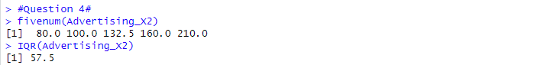
5. Write an R function to find the outliers in a numeric vector and check for outliers in years variables.  
   A screenshot of a computer code

   Description automatically generated